Section A
1). What are the core modules in the Spring Framework? [Choose two answers.]
a). Singleton Design Pattern.
b). Test Framework.
c). Front Controller Pattern.
d). Aspect Oriented Programming Framework.

2). What are the correct ways to include the Dependency Injection in Spring to a normal Java class?
[Choose two answers.]
a). Constructor way.
b). Parameter way.
c). Setter method way.
d). Injection way.

3). Select the correct definition to configure the Bean Scope as "singleton" in Spring's configuration
file when using the DI Framework?
a). <bean id="TestBean" class="TestClass" beanscope=“singleton" > .. </bean>
b). <beans id="TestBean" class="TestClass" scope=“singleton" > .. </beans>
c). <bean id="TestBean" class="TestClass" "singleton" > .. </bean>
d). <bean id="TestBean" class="TestClass" scope=“singleton" > .. </bean>

4).How is it possible to accurately configure a "lazy loading Bean" when using DI?
a). <bean id="TestBean" class="TestClass" scope=“singleton" > .. </bean>
b). <bean id="TestBean" class="TestClass" scope=“lazy_loading" > .. </bean>
c). <bean id="TestBean" class="TestClass" scope="singleton" lazy-init="true" > .. </bean>
d). <bean id="TestBean" class="TestClass" scope=“singleton" lazy-loading="true" > .. </bean>

5). What is the major difference between the "ApplicationContext" and the BeanFactory in DI?
a). BeanFactory can access the springConfig.xml directly but ApplicationContext cannot
b). BeanFactory always performs "lazy loading" and ApplicationContext perform "lasy
loading and "Pre-loading" both.
c). Default behaviour of BeanFactory is "Pre-loading".
d). Nothing.

6). Who are the "helpers" of Web MVC pattern in Spring?
a). Handler Mapping, Data Generator Guy, View Resolver, Final Response Builder Guy.
b). Front Controller and Model Object Creator.
c). Spring-config.xml, URL Reader, Model Object Creator, View Creator
d). JSTL Library, EL, Controller Class.

7). Who is the "Front Controller" in Web MVC in Spring ?
a). BeanController.
b). Dispatcher Servlet.
c). ModelandView Controller
d). Nothing.

8). Choose the two Handler Mapping Classes in Spring's Web MVC?
a). BeanNameUrlHandlerMapping.
b). AdvancedUrlMapping.
c). ServletNameHandlerMapping.
d). ControllerClassNameHandlerMapping.

9). What is the main configuration element of Spring's Web MVC annotation based mapping?
a). xmlns:p="http://www.springframework.org/schema/p"
b). <context:annotation-config/>
c). <context:component-scan base-package="src"/>
d). xmlns:tx="http://www.springframework.org/schema/tx"

10). Identify and select the correct definition of the annotation that maps a request? (Annotation based mapping.)
a). @MaptheRequest("/index.htm")
b). @RequestMapping("/index.htm")
c). @RequestMapping(from="/index.htm")
d). @Mapping("/index.htm")

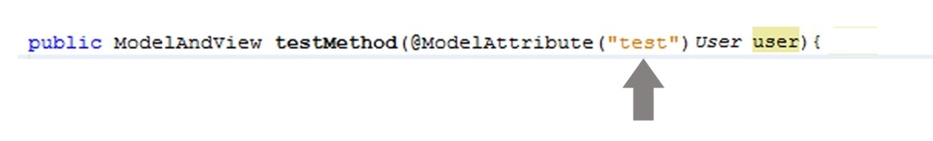
11). What is the definition of the "test" parameter in ModelAttribute annotation?
a). It is a only parameter and nothing else.
b). We can access the "User" object anywhere in a controller class via "test" Parameter.
c). Automatically binds the "data" object to ModelandView Object" via "test" Parameter.
d). It is a Parameter of the annotation Structure.

12).Select two cross cutting concerns in programming techniques?
a). Logging.
b). Encapsulation.
c). Transactions.
d). Polymorphism.

13). What is the main configuration element of Spring's AOP?
a). <aspectj:annotation-config/>
b). <aspectj- config/>
c). <context:component-scan/>
d). <aop:aspectj-autoproxy/>

14).What is the meaning of the following annotation in Spring's AOP?
@Before("execution(public get*(..))")
a). Before executing any get type method.
b). Before executing any get type method with "0" or more arguments.
c). Before executing any get type method with arguments.
d). Before executing only a get method.

15).How can we recognise an ASPECT Java class from a normal Java class? [Choose one answer.]
a). Because of "@Before" annotation.
b). Because of "@After" annotation.
c). Because of "@Aspect" annotation.
d). Because of "@execution" annotation

Section B
01) Create an annotation based controller class for the following requirement.
-- class name "IndexController".
-- Mapping Method - "setHeader".
-- Mapping request from "index.htm"
-- Forward ModelandView Object to "Home.jsp" with a "header" param.
-- use "header" value as "Welcome My Site...".
Ignore the Add Imports.......

